MindBridge AI: An Intelligent Multi-Agent Mental Wellness and Accessibility Platform for Disabled Individuals
Kakunuri Yasaswi  Department of Computer Science and Engineering  KLH CSE Bowrampet Campus  Hyderabad, India | Muduganti Sahithi Reddy  Department of Computer Science and Engineering  KLH CSE Bowrampet Campus  Hyderabad, India | Dr. Srikanth Cherukuvada  Assistant Professor  Department of Computer Science and Engineering  KLH CSE Bowrampet Campus  Hyderabad, India

Abstract—Mental-health support tools are rarely designed with disabled users in mind. Most digital wellness applications are monolithic, text-first chat interfaces that assume a person can read, type and navigate a screen unaided, which leaves people with visual, hearing, speech, motor or cognitive impairments with few usable options when they need timely emotional support. Existing multi-agent mental-health systems improve personalization and safety but treat accessibility as an add-on, and speech-accessibility research is evaluated on recognition benchmarks rather than inside a working wellness platform. This paper presents MindBridge AI, a multi-agent mental wellness and accessibility platform built as five independently deployable FastAPI microservices (orchestrator, crisis, wellness, accessibility and speech), each containerized with Docker. A LangGraph state graph in the orchestrator always screens a message for crisis risk first and short-circuits to a crisis response when a high-risk phrase is found, bypassing the wellness crew. A three-agent wellness crew tags emotion, topic and intensity, and a dedicated accessibility service rewrites each reply for visual, hearing, speech, motor or cognitive needs. Whisper speech-to-text with a browser Web Speech fallback supports voice input. A preliminary evaluation of the working prototype shows 16 of 16 automated tests passing; a median end-to-end latency of 88–101 ms on the normal path and 33 ms on the crisis path on a single machine; and, on a 35-message author-constructed set, crisis-detection precision of 90.9% with recall of 62.5%. Every explicit high-risk phrase was caught, but none of six paraphrased expressions were. The results show why crisis detection must be reported with recall rather than accuracy alone, and they motivate a learned classifier as the next step.
Index Terms—Multi-agent systems, mental wellness, accessibility, service-oriented architecture, microservices, LangGraph, CrewAI, Whisper, crisis detection, assistive technology
I. Introduction
Mental-health conditions affect roughly a billion people worldwide, and most of them receive little or no care [1]. Conversational agents are one of the few interventions that can scale to that gap. A fully automated cognitive-behavioral-therapy chatbot reduced depressive symptoms in a randomized trial with young adults [2], an empathy-oriented agent was evaluated on real-world usage data [3], and systematic reviews report encouraging results alongside thin and uneven evidence on safety [4].
These systems share an assumption that is rarely stated: the user can read the screen, type a reply and follow a visual layout. For a person with a visual, hearing, speech, motor or cognitive impairment, each of those assumptions can be a barrier at the moment support is most needed. Web accessibility standards such as WCAG 2.2 already describe how content should be made perceivable, operable, understandable and robust [5], yet mental-health chatbots are seldom engineered around them. Speech is a natural alternative to typing, but recognition accuracy drops for impaired speech, which is why the Interspeech 2025 Speech Accessibility Project (SAP) Challenge was organized around more than 400 hours of speech from people with speech disabilities [6].
A second problem is architectural. Many digital mental-health tools are monolithic: wellness dialogue, safety checks and interface logic are tightly coupled, so adding crisis detection, voice interaction or a new accessibility profile means redesigning the whole system. Service-oriented architecture and microservices address exactly this concern by giving each capability its own contract, deployment and life cycle [7], [8]. Recent multi-agent systems for mental health show that decomposing a chatbot into specialized agents improves personalization and compliance [9], [10], [11], but they do not combine that decomposition with accessibility-first design.
This paper presents MindBridge AI, an intelligent multi-agent mental wellness and accessibility platform for disabled individuals. The prototype is built from five independently deployable FastAPI microservices [16] that are coordinated by a LangGraph [12] state graph and a CrewAI-style [13] wellness crew, use OpenAI Whisper [14] for speech recognition, and are containerized with Docker [15]. The contributions are:
- A five-service SOA decomposition in which the orchestrator, crisis, wellness, accessibility and speech capabilities each have their own folder, dependencies, container and JSON contract.
- A crisis-first orchestration policy. Every message is screened by a dedicated crisis service before anything else; an explicit high-risk phrase routes straight to a crisis response and the wellness crew is never called.
- An accessibility-adaptation service that rewrites each reply for five disability profiles and returns presentation metadata (read-aloud, quick replies, ARIA live-region mode).
- Voice input through Whisper, with an automatic browser Web Speech fallback so the feature never blocks on a model download.
- A reproducible, honestly scoped evaluation covering functional tests, crisis-detection precision and recall, latency, accessibility behavior and failure injection, including the weaknesses it exposed.
The rest of the paper follows the structure of the project: Sections II–V state the problem, objectives, related work and research gap; Sections VI–X describe the proposed system, architecture, methodology, novelty and implementation; Sections XI–XIV report the evaluation, discussion, limitations and future work; Section XV concludes.
II. Problem Statement
Four problems motivate this work. First, fragmented accessibility: people with visual, hearing, speech or motor disabilities are underserved by mainstream wellness apps built around text-only, single-agent chat. Second, monolithic architecture: tightly coupled applications are hard to scale, to extend with new capabilities or to adapt to diverse accessibility needs. Third, no unified platform: no existing solution combines multi-agent AI orchestration with accessibility-first design (speech-to-text, text-to-speech, adaptive presentation) delivered as independently deployable services. Fourth, coordination overhead: when wellness coaching, crisis monitoring and accessibility support are coordinated manually or through slow pipelines, response latency and risk both increase for a disabled user in genuine distress.
The research problem is therefore:
How can multi-agent AI orchestration, crisis detection, accessibility adaptation and speech interaction be integrated into a service-oriented platform that gives disabled users timely, empathetic and safe mental-wellness support, while keeping every capability independently deployable and testable?
III. Research Objectives
The main objectives of the proposed work are:
- To design a multi-agent architecture, using LangGraph and a CrewAI-style crew, that orchestrates wellness, crisis-detection and accessibility agents as independent microservices.
- To integrate Whisper-based speech-to-text and text-to-speech so that users who cannot type or see the screen can still interact.
- To expose every capability through FastAPI microservices that follow SOA principles and are containerized with Docker for independent scaling and deployment.
- To provide an accessible client with high-contrast and larger-text modes, screen-reader support and voice input. The Review-1 plan named a Flutter client; the prototype implements the client as a web application that consumes the same gateway API.
- To evaluate responsiveness, accessibility behavior and the reliability of crisis detection under realistic usage scenarios.
IV. Literature Review
A. Mental-Health Chatbots
Early chatbots were scripted. Woebot delivered cognitive-behavioral-therapy content through a rule-based dialogue and showed symptom reduction in young adults [2]. Wysa combined empathy-oriented dialogue with an engagement analysis on real-world data [3]. Systematic reviews conclude that chatbots are promising but that evidence on safety is limited [4]. None of these systems was designed around disability-specific interaction needs.
B. Multi-Agent Mental-Health Systems
MindCare [9] decomposes a companion chatbot into intent-recognition, memory, compliance, humanizer and correction agents around a fine-tuned LLaMA model with retrieval-augmented generation, and deploys the agents as RESTful services. Its authors note that it is English-only, that crisis escalation to human services is not yet integrated, and that voice interaction is future work. Copewell [11] routes users to specialized agents using a valence–arousal emotion map, integrates self-reported, physiological and contextual data, and places an Ethics Supervisor agent over safety rules. Both show that agent decomposition helps personalization and safety; neither makes disability accessibility a designed subsystem.
C. Orchestrated Health Agents
openCHA [10] is an open-source framework in which an orchestrator plans and invokes external tools and knowledge sources to produce personalized health responses. It reported 92.1% accuracy against 51.8% for GPT-4 alone in a diabetes-management use case, which supports the claim that orchestrated agents outperform a single model on multi-step tasks. Its focus is general healthcare rather than mental-wellness safety or disability access.
D. Speech Accessibility
Whisper was trained on 680,000 hours of weakly supervised multilingual audio and generalizes well to many speakers and accents [14]. The SAP Challenge [6] benchmarked recognizers on more than 400 hours of speech from over 500 people with speech disabilities; 12 of 22 valid teams beat a Whisper-large-v2 baseline on word error rate, and the best team reached 8.11%. Whisper is therefore a reasonable baseline for accessible voice input but needs adaptation for impaired speech. The challenge evaluates recognition only, not an end-to-end wellness platform.
E. SOA, Microservices and Accessibility Standards
Service-oriented computing organizes software as loosely coupled services with explicit contracts [7]. Microservices push the idea further, giving each service its own process and deployment so that it can be scaled, updated or replaced independently [8]. Containers make that deployment consistent [15]. WCAG 2.2 supplies the accessibility vocabulary [5]: content must be perceivable, operable, understandable and robust, which maps naturally onto per-profile adaptation of a reply and its presentation.
Table I summarizes how the closest systems compare on the capabilities that matter here.
TABLE I
Comparison with Related Work
System | Multi-agent | Safety agent | Voice | Disability adaptation | Indep. services
MindCare [9] | Yes | Yes | Planned | No | Yes
openCHA [10] | Yes | No | No | No | Framework
Copewell [11] | Yes | Yes | No | No | Concept
SAP Challenge [6] | No | No | ASR only | Speech only | No
MindBridge AI | Yes | Yes | Yes | Yes | Yes

V. Research Gap
The review identifies the following gaps.
A. Isolated Focus
Existing work addresses either conversational mental-health quality or speech accessibility, but not both inside a unified, service-oriented architecture.
B. Under-Used Orchestration
Multi-agent frameworks such as CrewAI and LangGraph have not been widely applied to jointly orchestrate wellness coaching, crisis detection and accessibility adaptation as independently deployable microservices.
C. Benchmark-Only Accessibility Research
Speech-accessibility studies evaluate models in isolation, without integrating them into a live, containerized wellness platform.
D. Accessibility Not Designed Into the Client
Little existing work connects an accessible client, with screen-reader support, adjustable contrast and text size, and voice input, to agentic back-end services for real-time, crisis-aware support.
E. Safety–Latency Gap
Coordination between wellness, crisis and accessibility components adds latency exactly where it is least acceptable. Few designs make the safety path structurally shorter than the ordinary path.
VI. Proposed System
MindBridge AI is a safety-first, accessibility-first pipeline. The central workflow is:
Receive → Screen → Route → Support → Adapt → Deliver → Remember
The system contains the following major components: (1) an accessible client; (2) an orchestrator with session memory; (3) a crisis-screening service; (4) a context agent that tags emotion, topic and intensity; (5) a support agent that drafts the reply; (6) a technique agent that attaches a coping exercise; (7) an accessibility-adaptation service; (8) a speech service for transcription and synthesis; (9) a per-node execution trace; and (10) a Docker Compose deployment with health checks. Unlike a single-model chatbot, no component is allowed to hold more than one responsibility.
A. Design Principles
Five principles shaped the design and are reflected in the code:
- One responsibility per service. Crisis detection classifies, the wellness crew drafts, the accessibility service reshapes, the speech service converts audio, and the orchestrator decides. No service does two of these jobs.
- The safety path is first and shortest. Screening precedes every other step, and a high-risk result removes the slower steps from the route.
- Coupling only through contracts. Services exchange JSON over HTTP and never import each other, so any service can be rewritten in another language.
- Offline by default. Every service works without an API key; heavier options (CrewAI, Whisper) sit behind the same contract and fall back automatically.
- Make decomposition and failure visible. Every node appends a trace entry with its latency, and an unreachable screener is recorded as UNKNOWN rather than treated as safe.
VII. System Architecture
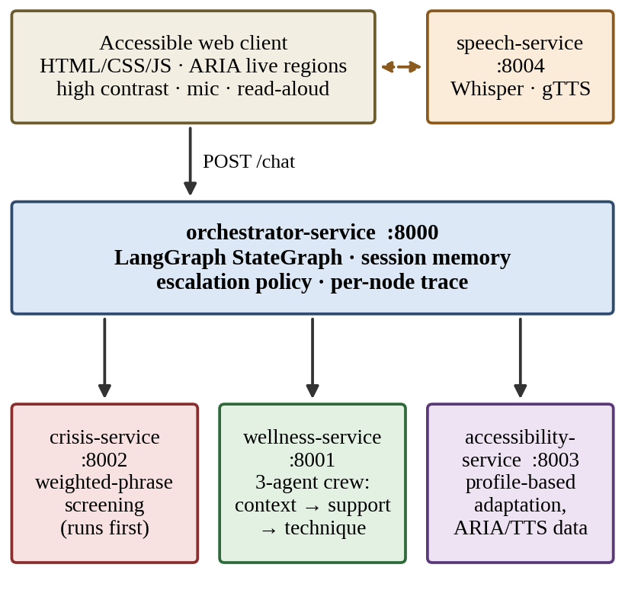
Fig. 1. MindBridge AI service architecture. The client talks to the orchestrator, which calls the crisis, wellness and accessibility services; the client calls the speech service directly. Each box is a separate container.
A. Presentation Layer
A web client with semantic HTML, a skip link, a live region for the conversation, visible keyboard focus, aria-pressed toggles, a high-contrast theme, two text sizes, reduced-motion support and the Atkinson Hyperlegible typeface. It renders the quick-reply buttons and the crisis banner returned by the gateway and shows the execution trace so the service decomposition is visible.
B. Orchestration Layer
The orchestrator service is the single public gateway. It owns session memory, the escalation policy and the LangGraph workflow, and it is the only service that calls the others. No service imports another service’s code; the only coupling is the JSON shape of four endpoints.
C. Safety Layer
The crisis service is a pure classifier. It never speaks to the user, so escalation policy stays with the orchestrator, and it can be monitored, tested or replaced by a trained model without touching any other service.
D. Wellness Layer
The wellness service runs a three-stage crew (context, support, technique). By default the stages execute as a deterministic in-process pipeline so the service works offline. If CREWAI_ENABLED and an API key are both set, the same three roles run as a CrewAI crew; any exception falls back to the deterministic pipeline.
E. Accessibility and Speech Layers
The accessibility service reshapes the final text per profile and returns presentation metadata. The speech service transcribes audio with Whisper and synthesizes speech with gTTS when installed; otherwise it answers with engine="browser" and the client uses the browser’s own speech APIs.
F. Deployment Layer
Each service has its own Dockerfile, requirements.txt and health endpoint. Docker Compose starts five containers with health checks; the orchestrator is configured with the other services’ URLs through environment variables. Table II lists the service contracts.
TABLE II
Service Contracts
Service | Port | Endpoints | Responsibility
orchestrator | 8000 | POST /chat; DELETE /session/{id}; GET /health | LangGraph routing, session memory, trace
crisis | 8002 | POST /analyze | Risk classification only
wellness | 8001 | POST /respond | Context → support → technique
accessibility | 8003 | POST /adapt | Profile adaptation, ARIA/TTS data
speech | 8004 | POST /transcribe; POST /speak | Whisper STT, gTTS, browser fallback

VIII. Methodology
A. Orchestration Workflow
The orchestrator builds a LangGraph StateGraph (Fig. 2). The state carries the session identifier, user message, accessibility profile, conversation history, crisis result, wellness result, final response and a trace list. The trace field is declared with an append reducer so that each node adds its entry rather than overwriting the previous one, which is what lets the complete route survive into the HTTP response. After loading context, the graph always runs crisis_check and then a conditional edge chooses between the crisis path and the wellness path.
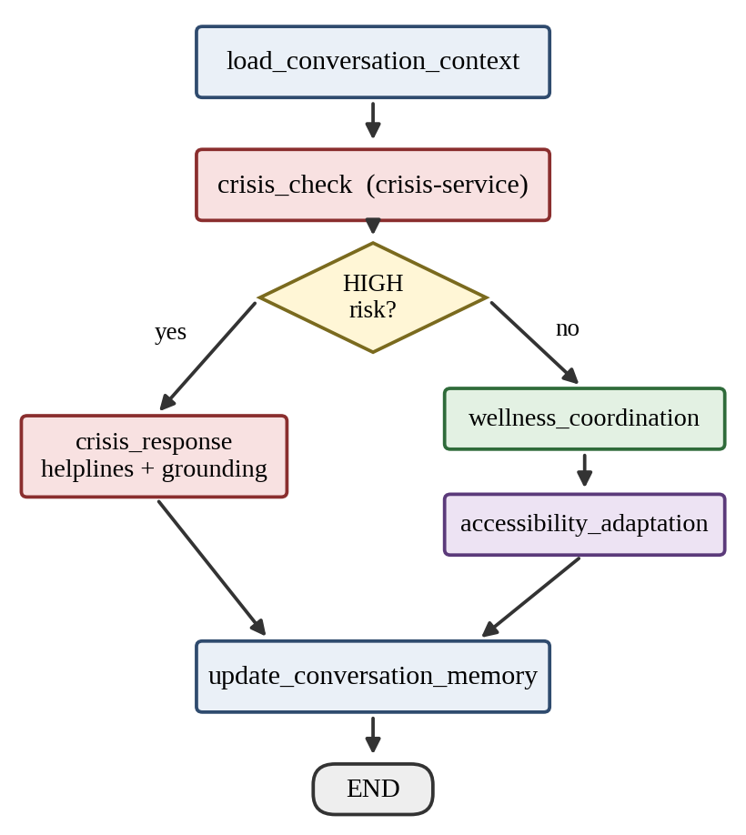
Fig. 2. LangGraph workflow. Crisis screening always runs first; a HIGH result skips the wellness crew and accessibility adaptation entirely.
B. Crisis Screening
The crisis service holds three weighted phrase tables: eight HIGH-risk phrases (weights 0.7–1.0), ten MODERATE phrases (0.4–0.6) and seven LOW phrases (0.15–0.25). After lower-casing and stripping punctuation, the service adds the weight of every phrase found in the message. Writing L(m) for the set of phrases found in message m and w_{p} for the weight of phrase p, the score is
S(m) = min( 1, Σ_{p ∈ L(m)} w_{p} ) (1)
A message is classified HIGH, and crisis_detected is set, only when at least one HIGH phrase is present. Otherwise it is MODERATE if S(m) ≥ 0.35 and NONE if not. This asymmetry is deliberate: several moderate words raise the score but cannot trigger the crisis bypass alone, because an escalation path that fires on ordinary sadness teaches users to ignore it. A HIGH result returns a fixed supportive message and a list of four helplines.
C. Routing and Latency Model
The conditional edge sends the message to crisis_response if crisis_detected is true and to wellness_coordination otherwise. If the screener cannot be reached, the node records risk_level=UNKNOWN in the trace. Because the crisis path skips two network calls, its latency is modeled as
T_{crisis} = T_{ctx} + T_{scr} + T_{esc} + T_{mem} (2)
T_{normal} = T_{ctx} + T_{scr} + T_{wel} + T_{acc} + T_{mem} (3)
so T_{normal} − T_{crisis} ≈ T_{wel} + T_{acc} − T_{esc}: the distressed user is never kept waiting on the slower wellness pipeline.
D. Wellness Crew
Context agent. Reads the message and recent history and tags one of six emotions (anxiety, low mood, frustration, exhaustion, loneliness, self-criticism, otherwise a general check-in), one of seven topics (work, school, family, relationship, health, money, future) and an intensity level. Intensity counts intensifiers such as “constantly” or “can’t take”, repeated exclamation marks and all-capital words: two or more hits is high, one is moderate.
Support agent. Drafts a non-diagnostic reply. The opening line is chosen from the variants for the detected emotion by the turn index, so a returning user hears a fresh sentence. The reply names the detected topic (“the pressure around school”), adds an intensity line for high-intensity messages, acknowledges that the user has raised the issue before, and ends with a follow-up question that changes for returning users.
Technique agent. Attaches a coping exercise (5-4-3-2-1 grounding, box breathing and others) selected from a per-emotion list, skipping exercises already offered earlier in the session.
E. Accessibility Adaptation
The accessibility service applies a profile-specific transformation and returns metadata so any client knows how to present the reply (Table III). Rule-based adaptation was chosen over an LLM rewrite because it is predictable, fast and auditable: the adaptations field is a machine-readable record of what was changed for whom.
TABLE III
Accessibility Profiles
Profile | Text transformation | Presentation metadata
visual | At most 3 sentences; sight words swapped (“look at” → “think about”) | Read aloud automatically, 130 wpm
hearing | Sound words swapped (“listen to”, “hear” → “read”) | Captions always on
speech | At most 3 sentences plus a yes/no question | Quick replies: Yes, No
motor | At most 3 sentences plus button prompt | Four quick-reply buttons
cognitive | Plain language, at most 3 sentences | Reading level “plain”

The metadata also carries a recommended font scale, the high-contrast flag and an aria_live_mode that becomes assertive when helplines are present so a screen reader interrupts instead of queueing.
F. Voice Pipeline
When the user presses Speak, the client records audio and posts it to the speech service. Whisper runs locally with the base model (no external API call) and the temporary file is deleted immediately after transcription. If Whisper is not installed, the service replies with engine="browser" and the client uses the Web Speech API. Replies are read aloud for the visual profile, when the read-aloud toggle is on, and always for crisis replies.
G. Session Memory
The orchestrator keeps an in-memory history per session identifier. The history is passed to the wellness service on every turn, which is what makes returning-user acknowledgement and phrasing rotation possible. A session can be cleared with a DELETE request.
H. Safety, Privacy and Ethics Considerations
Replies are written to be supportive and non-diagnostic, and every wellness reply carries a disclaimer that the platform does not replace medical or mental-health professionals. Whisper runs locally, so recorded audio is not sent to an external service, and the temporary audio file is deleted as soon as transcription finishes. Conversation history lives only in process memory and can be cleared per session. Helplines are returned only on a HIGH result and are fixed text, never generated, so a language model cannot alter safety-critical content. These measures reduce risk but do not amount to regulatory compliance for health data; see Section XIII.
IX. Novelty and Contributions
The novelty of MindBridge AI is not a new language model or classifier. It lies in the integration of multi-agent orchestration, crisis-first safety and accessibility adaptation into independently deployable services.
A. Accessibility as a First-Class Service
Disability accessibility is a separate, testable service with five profiles rather than a styling concern in the client. Equity-oriented systems such as Copewell [11] concentrate on cost and access barriers and do not specifically treat visual, hearing, speech, motor or cognitive needs.
B. Crisis-First Orchestration with a Separate Detector
Crisis detection is its own service and the first node in the graph. Separating detection from the rest of the safety logic makes it easier to test, monitor and update than a single supervising agent that mixes safety rules with other duties.
C. Accessible Delivery of a Controlled Crisis Message
The crisis text and helplines are fixed for safety, but their delivery adapts: the message is always read aloud, shown in an assertive live region and displayed as text, so crisis support becomes accessible without changing the safety information.
D. Message-Only Personalization and Voice Input
The wellness crew personalizes from the message itself (emotion, topic, intensity) and the conversation so far. It needs no wearable, calendar or sleep data, and users who find typing difficult can speak instead. Table IV condenses the contrast with the closest comparable system.
TABLE IV
Novelty over Copewell
Aspect | Copewell [11] | MindBridge AI
Accessibility focus | Cost, language and access barriers | Visual, hearing, speech, motor and cognitive needs
Input signals | Self-reported, physiological and contextual data | Message text only: emotion, topic, intensity
Crisis message | Predefined response | Fixed content, adaptive delivery (read aloud, assertive region)
Safety design | One Ethics Supervisor agent | Separate crisis service
Deployment | Described as a design concept | Five Dockerized services
Voice input | Standard interface | Whisper plus browser fallback

X. Technical Implementation
The prototype is implemented in about 1,900 lines of Python, HTML, CSS and JavaScript (services, tests and client). Table V lists the technology used for each layer.
TABLE V
Implementation Summary
Layer | Technology
Services | Python, FastAPI [16], Pydantic request models, CORS middleware, health endpoint per service
Orchestration | LangGraph StateGraph [12], async httpx calls (5 s timeout to crisis, 60 s to wellness)
Agents | Three-role crew; optional CrewAI [13] backend with Claude as the LLM
Speech | Whisper base [14] (local), gTTS, browser Web Speech API fallback
Client | Semantic HTML, CSS themes, vanilla JavaScript, ARIA live regions
Deployment | Docker [15] with Compose, five containers with health checks; run_all.py for a no-Docker run
Testing | pytest with FastAPI TestClient; no running service required

Two implementation choices are worth stating. First, the default wellness backend is deterministic so that a demonstration never depends on a network call or an API key; the CrewAI backend is optional and was not exercised in the evaluation below. Second, each service folder is self-contained, so any one of them could be rewritten in another language as long as it honors the same JSON contract.
The gateway contract is a single request and an enriched response. An abbreviated exchange for the cognitive profile is shown below.
POST /chat
{"message": "I can't sleep and I feel
overwhelmed at college",
"profile": "cognitive", "session_id": "s1"}
--> {"type": "wellness",
"risk_level": "MODERATE",
"emotion_detected": "anxiety",
"topic_detected": "school",
"reply": "...(max 3 sentences)...",
"coping_technique": {"title":
"5-4-3-2-1 grounding", ...},
"accessibility": {"adaptations":
["plain language", ...], ...},
"trace": [{"service": "crisis-service",
"action": "analyze", "ms": 29}, ...]}

XI. Experimental Evaluation
A. Setup
All measurements were taken on one Linux machine (Python 3.12). Latency was measured with the five services running as separate uvicorn processes on localhost, without Docker. Whisper was not installed, so the speech service ran in browser-fallback mode, and CrewAI was not enabled, so the wellness service used its deterministic pipeline. Network latency, model inference time and mobile devices are therefore not represented.
B. Functional Tests
The pytest suite contains 16 tests covering the three crisis bands, emotion tagging, offline operation, returning-user replies, every accessibility profile, the routing function, graph compilation and service health. All 16 passed.
C. Crisis-Detection Reliability
No public labeled set matches the phrase-based screener, so a 35-message evaluation set was constructed by the authors: 10 explicit crisis statements, 6 paraphrased crisis statements with no listed phrase, 10 non-crisis distress messages, 6 neutral messages and 3 hard negatives. A message counts as positive when crisis_detected is true. With TP, FP, FN and TN denoting the usual outcomes, precision is P = TP/(TP+FP), recall is R = TP/(TP+FN) and
F₁ = 2PR / (P + R) (4)
TABLE VI
Crisis Detection on the 35-Message Set
Outcome / metric | Count | Value
True positives | 10
False positives | 1
False negatives | 6
True negatives | 18
Accuracy |  | 80.0%
Precision |  | 90.9%
Recall |  | 62.5%
F1-score |  | 74.1%

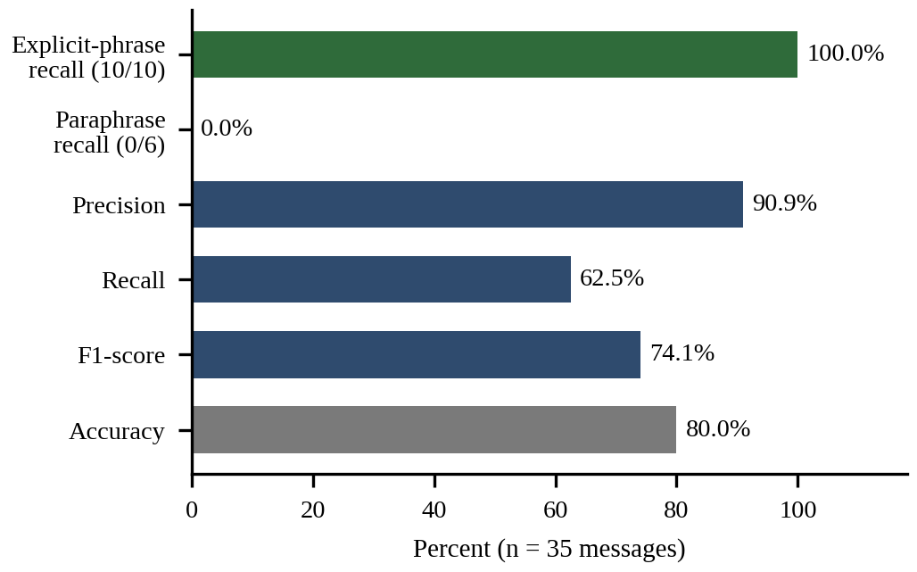
Fig. 3. Crisis-detection results. Recall is perfect on explicit phrases and zero on paraphrases, which an aggregate accuracy of 80% conceals.
All 10 explicit statements were detected, but none of the 6 paraphrases (for example, “I don’t want to be alive anymore”) was, so overall recall is 62.5%. The single false positive was a negated sentence, “I don’t want to die, I just want my pain to stop”, which contains a listed phrase. Eight of the ten non-crisis distress messages were correctly flagged MODERATE without escalating; the other two (“lonely” and “overwhelmed” alone) scored below the 0.35 threshold. The pattern mirrors a familiar lesson in failure prediction: high accuracy and high precision say little about how many true cases are missed.
D. Latency
Table VII reports in-process service latency (300 calls each, no network) and Fig. 4 reports end-to-end latency through the gateway over HTTP (100 requests per scenario).
TABLE VII
In-Process Service Latency (ms)
Service call | Median | 95th pct.
crisis /analyze | 1.9 | 2.1
wellness /respond | 1.9 | 2.2
accessibility /adapt | 2.0 | 2.3

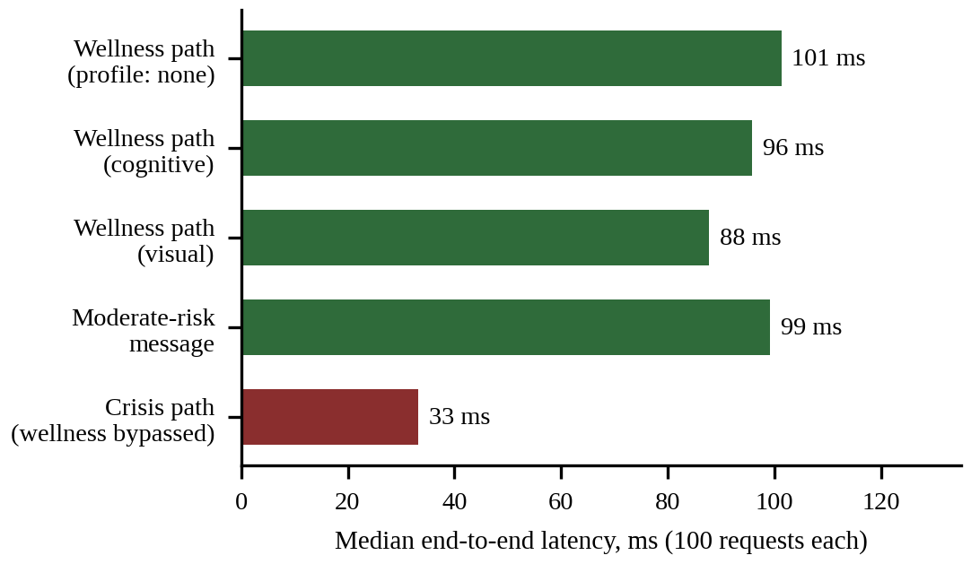
Fig. 4. Median end-to-end latency through the gateway. The crisis path skips the wellness and accessibility calls.
Each service does its own work in about 2 ms, yet each hop costs 25–30 ms in the trace, which suggests that inter-service HTTP overhead, not computation, dominates. The normal path takes 88–101 ms at the median (95th percentile 117–145 ms). The crisis path takes 33 ms (95th percentile 51 ms), about one third of the normal path, which confirms the benefit predicted by Eqs. (2) and (3).
Table VIII breaks the median down by workflow node, using the trace that the orchestrator returns with every reply. The orchestrator’s own steps cost under a millisecond, the three service calls cost 29–31 ms each, and about 12 ms is spent outside the nodes in the gateway itself.
TABLE VIII
Median Time per Workflow Node (ms)
Node | Service | Normal | Crisis
load_context | orchestrator | 0 | 0
crisis_check | crisis | 29 | 26
wellness_coordination | wellness | 29 | –
accessibility_adaptation | accessibility | 31 | –
escalate | orchestrator | – | 0
update_memory | orchestrator | 0 | 0
End-to-end (HTTP) |  | 101 | 33

E. Accessibility Behavior
The same five-sentence reply was passed through every profile (Table IX). Each profile changed the text and metadata as designed. Two small defects appeared: the visual profile lower-cases the first word after a substitution (“think about the way…”), and it swaps “look at” but leaves “hear” unchanged.
TABLE IX
One Reply Through Each Profile
Profile | Sentences out (in: 5) | Quick replies | Read aloud
none | 5 | 0 | No
visual | 3 | 0 | Yes
hearing | 5 | 0 | No
speech | 5 | 2 | No
motor | 4 | 4 | No
cognitive | 3 | 0 | No

F. Failure Injection and Personalization
With the speech service stopped, typed chat continued normally, as the fault-isolation design intends. With the crisis service stopped, the message “I want to die” was recorded as risk_level=UNKNOWN but was still routed to the wellness path and answered without helplines. The system therefore records the failure but does not yet fail safe (Section XIII).
A three-turn exam-stress dialogue showed the personalization working in part. The opening line changed on every turn, the topic was named, and the second and third turns acknowledged the earlier mention and asked a different follow-up question. The coping technique, however, stayed at “5-4-3-2-1 grounding” on all three turns, because the stored history contains the reply text rather than the technique title that the rotation logic searches for.
G. Threats to Validity
Several factors limit how far the results generalize. The crisis set was written by the authors who also know the phrase lists, which favors the screener on the explicit cases. All messages are in English and short. Latency was measured on one machine with localhost networking, so real deployments with Docker networks, cloud hosts or an LLM-backed wellness crew will be slower. The deterministic wellness pipeline is far cheaper than a CrewAI crew, so the normal-path numbers do not represent that option. Finally, no participants were involved, so nothing here measures whether the adapted replies are actually easier to use.
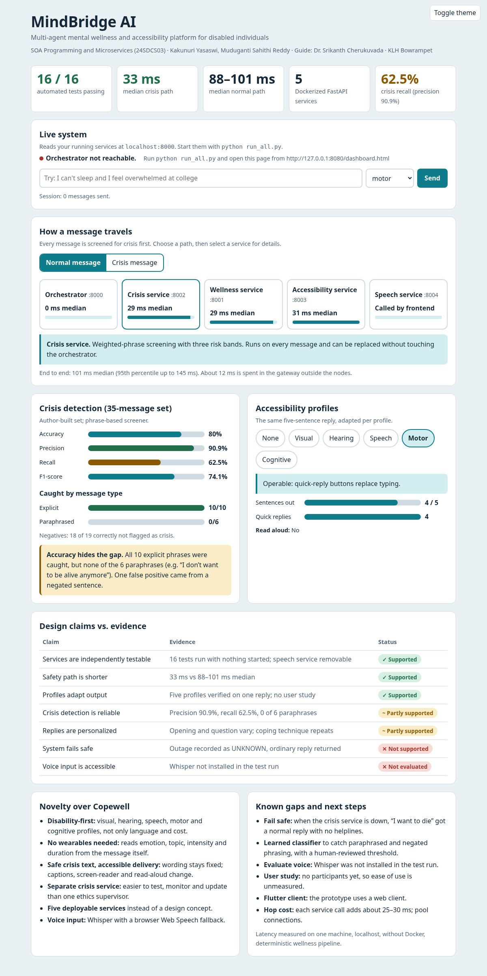
Fig. 5. Output of the MindBridge AI project dashboard after execution, showing the measured evaluation results, workflow latency, crisis-detection metrics, accessibility profiles and design-claim evidence.
XII. Discussion
The evaluation supports the architectural claims and qualifies the safety claims. Independent services behaved as intended: the speech service could be removed without affecting typed chat, each service answered in about 2 ms by itself, and the crisis path was about three times faster than the normal path. The crisis-first graph made the safety path structurally shorter, which is the load-bearing design decision.
The crisis results are the main caution. The screener has high precision (90.9%) but recall of 62.5%, and its recall on paraphrase was zero. For a safety function a missed case costs far more than a false alarm, so the escalation rule that requires an explicit phrase, chosen to keep escalations meaningful, needs to be paired with a learned classifier and a human-reviewed threshold. Because crisis detection is a separate service with a one-endpoint contract, it can be replaced without touching the orchestrator, which is the practical benefit of the decomposition.
Decomposition has a price. Each extra service adds an HTTP hop of roughly 25–30 ms in this prototype, and the orchestrator is a single point of coordination. For a conversational interface that cost is acceptable, since the normal path stays near 100 ms, but it argues for pooled connections and for keeping the number of services on the critical path small. Table X summarizes which design claims the evidence supports.
TABLE X
Design Claims and Supporting Evidence
Claim | Evidence | Status
Services are independently testable | 16 tests run with nothing started; speech service removable without affecting typed chat | Supported
Safety path is shorter | 33 ms against 88–101 ms median | Supported
Profiles adapt output | Five profiles verified on one reply (Table IX) | Supported; no user study
Crisis detection is reliable | P 90.9%, R 62.5%; 0 of 6 paraphrases | Partly supported
System fails safe | Outage recorded as UNKNOWN, ordinary reply returned | Not supported
Replies are personalized | Opening, topic and question vary; technique repeats | Partly supported
Voice input is accessible | Whisper not installed in the test run | Not evaluated

The profiles can also be read against the WCAG principles [5] (Table XI). This is the design rationale for each adaptation, not a claim of formal conformance.
TABLE XI
Profiles and the WCAG Principle They Serve
Profile | Principle | How the adaptation serves it
visual | Perceivable | Audio output replaces reading; sight-based wording removed
hearing | Perceivable | Text and captions always present; sound-based wording removed
speech | Operable | A yes/no answer replaces composing a sentence
motor | Operable | Quick-reply buttons replace typing
cognitive | Understandable | Plain language, three sentences, one idea each

Accessibility adaptation by rules is simple and transparent, and its output is easy to verify, but its quality depends on the vocabulary lists and it has not been validated with disabled users. MindBridge AI provides supportive information and emergency routing; it does not replace medical or mental-health professionals.
XIII. Limitations
The evaluation set is small, was written by the authors and has not been clinically validated, so the percentages should be read as an illustration of failure modes rather than as performance estimates. The screener is phrase-based, English-only and cannot handle paraphrase, sarcasm or negation. When the crisis service is unreachable, the current workflow records UNKNOWN but continues down the ordinary wellness path; a conservative fallback that returns helplines is required before real use.
Technique rotation does not currently work because the session history does not store the technique title. Session memory is a dictionary inside one process, so it is lost on restart and not shared across replicas. There is no authentication or encryption between services, which matters for health-adjacent data. Whisper was not benchmarked on impaired speech, and the SAP Challenge indicates that adaptation is needed for that population [6]. No user study with disabled participants and no formal WCAG audit has been done. The Flutter client from the Review-1 plan has not been built, and the CrewAI backend was not evaluated.
XIV. Future Work
Safety work comes first: a learned, multilingual crisis classifier with a human-reviewed threshold, evaluated on a clinically validated labeled set, and a fail-safe fallback that returns helplines whenever screening is unavailable. For architecture, a Redis-backed memory service would add a sixth independent service and make replicas stateless, service-to-service tokens and transport encryption would secure the contracts, and shared HTTP connection pooling should reduce the 25–30 ms per-hop cost. For accessibility, Whisper should be fine-tuned on impaired speech such as the SAP corpus [6], a Flutter client should be added on the same gateway API, and a user study with disabled participants and a WCAG audit should replace the current rule-of-thumb validation. Finally, the CrewAI backend should be evaluated against the deterministic pipeline for response quality.
XV. Conclusion
This paper presented MindBridge AI, a multi-agent mental wellness and accessibility platform for disabled individuals, built as five independently deployable microservices coordinated by a crisis-first LangGraph workflow. The prototype combines a three-agent wellness crew, a per-profile accessibility service and Whisper-based voice input, and all 16 automated tests pass. Measured on one machine, the crisis path answered in about 33 ms against 88–101 ms for the normal path. The same evaluation exposed a clear weakness: the phrase-based crisis screener detected every explicit statement but none of the paraphrases. The main contribution is therefore the integration of orchestration, safety and accessibility into a service-oriented platform whose weakest component can be replaced independently, together with an evaluation honest enough to show where that replacement is needed.
References
[1] World Health Organization, World Mental Health Report: Transforming Mental Health for All. Geneva, Switzerland: WHO, 2022.
[2] K. K. Fitzpatrick, A. Darcy, and M. Vierhile, “Delivering cognitive behavior therapy to young adults with symptoms of depression and anxiety using a fully automated conversational agent (Woebot): A randomized controlled trial,” JMIR Mental Health, vol. 4, no. 2, p. e19, 2017.
[3] B. Inkster, S. Sarda, and V. Subramanian, “An empathy-driven, conversational artificial intelligence agent (Wysa) for digital mental well-being: Real-world data evaluation mixed-methods study,” JMIR mHealth uHealth, vol. 6, no. 11, p. e12106, 2018.
[4] A. A. Abd-Alrazaq et al., “Effectiveness and safety of using chatbots to improve mental health: Systematic review and meta-analysis,” J. Med. Internet Res., vol. 22, no. 7, p. e16021, 2020.
[5] World Wide Web Consortium, “Web Content Accessibility Guidelines (WCAG) 2.2,” W3C Recommendation, Oct. 2023.
[6] X. Zheng et al., “The Interspeech 2025 Speech Accessibility Project Challenge,” in Proc. Interspeech, 2025 (arXiv:2507.22047).
[7] M. P. Papazoglou, “Service-oriented computing: Concepts, characteristics and directions,” in Proc. 4th Int. Conf. Web Information Systems Engineering (WISE), 2003, pp. 3–12.
[8] N. Dragoni et al., “Microservices: Yesterday, today, and tomorrow,” in Present and Ulterior Software Engineering, M. Mazzara and B. Meyer, Eds. Cham, Switzerland: Springer, 2017, pp. 195–216.
[9] V. Pattar, T. Patil, B. Dhuri, A. Karel, A. Deole, and S. Kulkarni, “MindCare: A multi-agent AI architecture for personalized and responsible mental health support,” Int. J. Res. Sci. Innov. (IJRSI), vol. 12, no. 5, 2025, doi: 10.51244/IJRSI.2025.120500181.
[10] M. Abbasian, I. Azimi, A. M. Rahmani, and R. Jain, “Conversational health agents: A personalized large language model-powered agent framework,” JAMIA Open, vol. 8, no. 4, p. ooaf067, 2025, doi: 10.1093/jamiaopen/ooaf067.
[11] S. Yenikent, J. Vinijtrongjit, and K. Ng, “Copewell: A multi-agent swarm architecture for equitable mental wellness support,” arXiv:2607.02245, Jul. 2026.
[12] LangChain, “LangGraph documentation.” [Online]. Available: https://langchain-ai.github.io/langgraph/
[13] CrewAI, “CrewAI documentation.” [Online]. Available: https://docs.crewai.com
[14] A. Radford, J. W. Kim, T. Xu, G. Brockman, C. McLeavey, and I. Sutskever, “Robust speech recognition via large-scale weak supervision,” in Proc. 40th Int. Conf. Machine Learning (ICML), PMLR vol. 202, 2023, pp. 28492–28518.
[15] D. Merkel, “Docker: Lightweight Linux containers for consistent development and deployment,” Linux J., vol. 2014, no. 239, Mar. 2014.
[16] S. Ramírez, “FastAPI documentation.” [Online]. Available: https://fastapi.tiangolo.com

